Dark Fortress
C&C Generals Zero Hour Map
By: Drummin

Three Maps In One
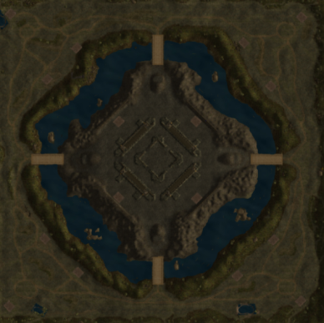

Dark Fortress Plays Three Ways:
AOD ~ Art of defense style map featuring a Fortress Player scripted for all factions.
Human Fortress Player ~ Human plays against four players and receives all fortress buildings.
Skirmish ~ Play as a four-player skirmish map with many tech buildings to capture in the center.

AOD Style:
Do you like playing AOD type maps playing against impossible odds?
Would you like to pick the faction and the speed of the AOD player?
Would you like to play an AOD map with the help of human or AI players?

Unlike most AOD maps, which are scripted for one faction (usually GLA) and made for only human players, Dark Fortress uses unique scripting allowing you to pick the faction and speed of the AOD attack. Each faction plays the fortress position a little different both in timing of attacks and the units they use. That keeps things interesting. The Fortress is designed to take out Four AI players on hard setting. Instead of huge waves sweeping over the map, the Fortress player’s strength will start small and continue to grow until it wipes you off the map… or at least that’s what the Fortress player thinks. He writes the following warning to you.

“As the ruler of the Dark Fortress, I demanded that all people leave MY land and will wipe out all those who oppose me. Any attempt to use Super Weapons will be dealt with in kind and retaliation for using Generals Attacks will also not be pretty. You China players can make your upgrades at the Propaganda Center but whatever you do, you’d better move fast as I will only get stronger with time."

So… Will you be the one to stop the fortress?

Human Fortress Player
A Human player in the fortress position receives all fortress buildings for the faction they're playing at the beginning of the game. This would include the Tech building for their faction, eight Barracks, four War and Air factories if applicable and over sixty Turrets and Artillery platforms. This player does not get scripted teams or Avenger Enhanced Turrets like the AOD Fortress player but Super Weapon countermeasures are still in place

Skirmish Style
Keeping the center position open activates a different set of scripts making it more of a king of the hill type map. The player who controls the center section of the map will have many advantages. Buildings up from grabs include four Oil Derricks, four Reinforcement Pads, four Boss War Factories, twenty Artillery Platforms and an Oil Refinery. With bridge-only access, many buildable areas and four Supply Docks to keep you going, this area is a great place to make a stand against stronger players.

Player Relationships
Player relationships between the fortress position and the other four positions are scripted to be enemies. This is true in both AOD and Human player modes. The relationships of the other four positions are not scripted so if you want to play 2 vs 2 vs The Fortress you can. I recommend you set all players to be on your team when starting out and the scripting will take care of the rest.

Many months of scripting went into this map. Hope you enjoy it.

Tips
Don’t use any generals-attack or even start building a super weapon as the fortress responses with a scud storm bath. Not fun.

Each attacking and defensive team is spawned if the building where they originate is still alive and well, so if you want to take out the fortress, take out each barrack and war factory when you can.

The timing of the fortress attacks is lengthened when you set the fortress general at an easier level. So if you can’t get going against a hard general, try normal or easy.

The fortress is scripted to play against four-players, so add skirmish players where you have any open positions. Then again, if you find hard is too easy, take on all four-fortress armies and see how you do.

The fortress strength compounds as new attack teams are added. Move out and attack as soon as you can too weaken their defenses and take out base structures. Once allied players are lost, those fortress teams will go after the next closest enemy, so this in not a map for bunkering down and turtle. Play defensive for sure but you must attack to win.

If playing in the fortress position, you will need to tell the default supply collectors to use their supply center. After this, these collectors should work just fine and continue their job.

